
16-18 Bursary Fund Application Form 2025/26
All applications for the bursary should be submitted prior to enrolment, or at least 4weeks after start date. This will enable us to correctly and fairly assess the overall demand and distribute discretionary awards. Payments can only be backdated up to 4weeks. We understand, however, that some needs may arise throughout the academic year. There will be no cut-off date for any application, in order to ensure learners’ needs can be met throughout the academic year.
For an application to be successful, all learners must meet the agreed standards for attendance and behaviour set by the institution. Learners must adhere to the Learner Code of Conduct and Behavioural Policy and have a minimum attendance rate of 85 percent at timetabled lessons to continue to be eligible for a bursary. Authorised absences will not affect a learner’s eligibility for the bursary. Vacation breaks and unauthorised absences are not permitted during term time and will affect their eligibility.
We assess each application on a case-by-case basis and eligibility does not entitle any learner to receive the bursary. If a learner is eligible for a vulnerable bursary, but we do not believe the learner requires it, e.g. there are no financial needs, or financial needs are already met via alternative means, we may not allocate the learner a bursary, or may offer a reduced amount of funding.
Please complete the form and email it to studyprogramme@hoopleltd.co.uk with your supporting evidence or post back to Hoople Study Programme, Hoople Ltd, Auxilium House, Legion Way, Hereford, HR1 1LN
Section A: Learner details
Title:

First Name & Surname:

Address:

Telephone Number:

National Insurance Number:

Date of Birth: Age:
Section B: Parent/Guardian details
Full Name:

Telephone Number:

Email address: :

Section C: 16 -18 Vulnerable Bursary
This section is for learners who may be eligible for a vulnerable bursary of up to £1,200.
To qualify you must be aged 16 or over and under 19 on 31 August 2025 and fall into one of the below categories.
Vulnerable bursary
Please tick as appropriate, supporting evidence MUST be submitted, see below for evidence details
Currently looked after in care-aged 16 or 17 at 31 August 2025?  Evidence required: Written confirmation, such as a letter or an email, of current looked-after child status from the relevant local authority (the local authority that looks after them or provides their leaving care services) | ◻ Yes | ◻ No
Care Leaver / Special Guardianship - aged 18 or over and previously was a looked after child.  Evidence required: Written confirmation, such as a letter or an email, of Care Leaver / Special Guardianship status from the relevant local authority (the local authority that looks after them or provides their leaving care services) | ◻ Yes | ◻ No
Learner is personally in receipt of Income Support or Universal Credit?  Evidence required:  A copy of the learners Income Support award notice, which must evidence that the learner is entitled to the benefit in their own right and confirm that the learner can be in further education or training  Or  Three months copies of the learners Universal Credit Award notice this must evidence that the learner is entitled to the benefit in their own right, as well as additional documentation to confirm their independent status, e.g. a tenancy agreement in the learner’s name, a Child Benefit receipt, a child’s birth certificate or utility bills | ◻ Yes | ◻ No
Disabled learner in receipt of Employment Support Allowance, Universal Credit or Disability Living Allowance/Personal Independence Payments in their own right.  Evidence required: Award letter showing in receipt of Employment Support Allowance, Universal Credit or Disability Living Allowance or Personal Independence Payment | ◻ Yes | ◻ No

Section D: Discretionary Bursary

Note: Do not complete if section C applies

Applicants should note that the discretionary bursary fund is limited, applications will be considered on a first come, first served basis.
Household income is one criteria that will help us to assess your application.
Discretionary Bursary
Low annual HOUSEHOLD income. Annual Income Amount: £  This income is for your HOUSEHOLD if you are a single parent this would be just your income however if you are married or living with a partner you MUST include your partners income.  Evidence required:  - Full TCAN Notice  Award notice or letter from DWP or HMRC  - In receipt of Universal Credit  Copies of the Universal Credit Award notice from the last three months, which must evidence that the learner is entitled to the benefit in their own right, as well as additional documentation to confirm their independent status, e.g. a tenancy agreement in the learner’s name, a Child Benefit receipt, a child’s birth certificate or utility bills  - P60  Most relevant April P60 statement  - Self-employed earnings  Most recent tax return  - Other benefits/pension | ◻ Yes | ◻ No

Section E: Free Meals
Free meals are targeted at disadvantaged learners. For the purposes of eligibility for free meals, ‘disadvantage’ is defined by the learner being in receipt of, or having parents who are in receipt of, one or more of the following benefits.
Household income and circumstances
Please tick as appropriate, supporting evidence MUST be submitted, see below for evidence details
Income support  Evidence required: Award notice or letter from DWP or HMRC | ◻ Yes | ◻ No
Income based jobseekers allowance (ESA)  Evidence required: Award notice or letter from DWP or HMRC | ◻ Yes | ◻ No
Support under part V1 of the immigration and Asylum Act 1999  Evidence required: Award notice or letter from DWP or HMRC | ◻ Yes | ◻ No
The guarantee element of State Pension Credit  Evidence required: Award notice or letter from DWP or HMRC | ◻ Yes | ◻ No
Child Tax Credit (provided they are not entitled to working tax credit) and have an annual gross income of no more than £16,190, as assessed by HMRC  Evidence required: Award notice or letter from DWP or HMRC | ◻ Yes | ◻ No
Working Tax Credit run-on- paid for 4weeks after you stop qualifying for Working Tax Credit  Evidence required: Award notice or letter from DWP or HMRC | ◻ Yes | ◻ No
Universal Credit with net earnings not exceeding the equivalent of £7400 pa after tax and not including any benefits you receive.  Evidence required: Three months copies of your Universal Credit Award notice, which must evidence that parent/guardian is entitled to this benefit.  Net earnings must not exceed the equivalent of £7,400.00 pa after tax and not including any benefits received. | ◻ Yes | ◻ No

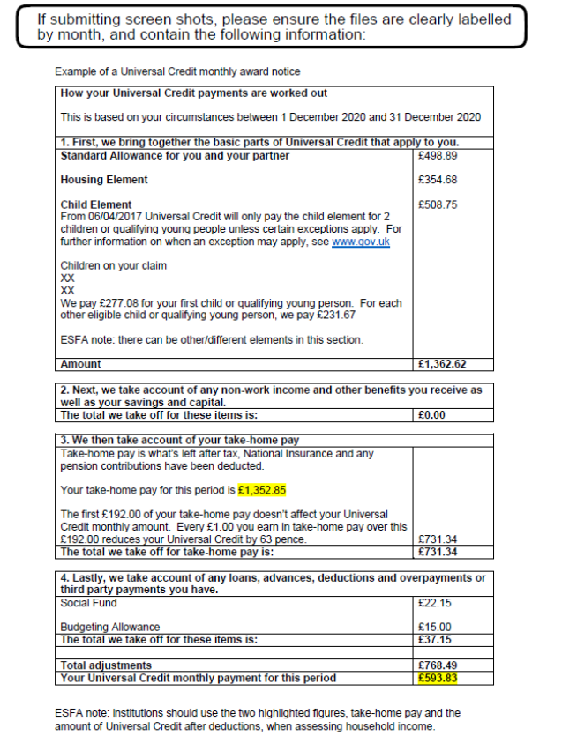

Providing false information
Learners and parents/guardians must be aware that any evidence provided to support this application must be valid. We have the right to investigate any false information supplied. We will stop further payments, and attempt to recover any past payments, where it is apparent that supplied information is misleading or fraudulent.
If significant fraud is identified, we will report this to the Education and Skills Funding Agency and may also report it to the police. Significant fraud involves the following:
● Amount of money is in excess of £1,200.
● Particulars of the fraud are novel, unusual, systematic or complex.
● Likely to be great public interest due to the nature of the fraud or the people involved.

Maintaining confidentiality
Any information given to the setting will only be used for the purpose of processing the learner’s application for a bursary. The learner’s information, eligibility or application (whether successful or not) will not be shared with other learners or staff members. Where we deem it necessary to share this information, we will only do so with the learner’s consent, unless the law permits us to do so without. We understand the need for maintaining confidentiality and appreciate that applications for the bursary are sensitive.
The setting has the duty to protect public funds that are handled by the school. The information provided in this form may be used to prevent and detect fraud. For the same reason, the information provided may be shared with third party organisations who handle public money. The learner will be informed if their information is being shared, in accordance with the GDPR. The information will be held in accordance with storage requirements defined by the GDPR and will be held for as long as necessary.
Section H – Declaration
I confirm that the information provided in this application is accurate and correct. I understand that any incorrect information provided will lead to the rejection of the 16-19 bursary application. If any information presented in the form changes, I will inform the setting immediately to ensure funding is allocated correctly.
Name (Learner): | Signed: | Date:
Name (Parent/Guardian): | Signed: | Date:

Parent/Guardian Final Checklist

Use this checklist to ensure you have everything prepared to submit your application.

Section A: Learner details

Section B: Parent/Guardian details

Section C: 16 -18 Vulnerable Bursary (if applicable)

Section D: Discretionary bursary (if applicable)

Section E: Free Meals (if applicable)

Provide Supporting evidence

Learner Signature

Parent/Guardian Signature

For office use only
Completed by (name):
Date of review:
Has the learner’s application been accepted or declined? | ◻ Accepted learner eligible and relevant evidence present.  Complete further details below |  | ◻ Declined application does not meet eligibility criteria include details below  ____________________________________________________________________________________________________
Which bursary/free meals application has been approved? | ◻ Vulnerable bursary | ◻ Discretionary bursary |  | ◻ Free Meals
Bursary Assessment details:
Amount of financial support awarded, estimated cost of essential equipment, travel, and other course related costs, and how the items will be purchased, or payments made to learners for the items where purchase is not possible?
Free Meals Assessment details:
Assessment details, how many days a week does the learner attend college and work placement and require free meals? Plan to ensure the learner receives the meals:

